Algebra 1: Unit 8, Lesson 2

- An equation is shown.
$y=(x+7)(x+3)$
What is the vertex of the graph?

$$(-5,-4)$$

- What values do the domain and range represent?
The domain represents the x-values and the range represents the y-values

- Functions $B$, $N$ and $S$ are shown in the table.
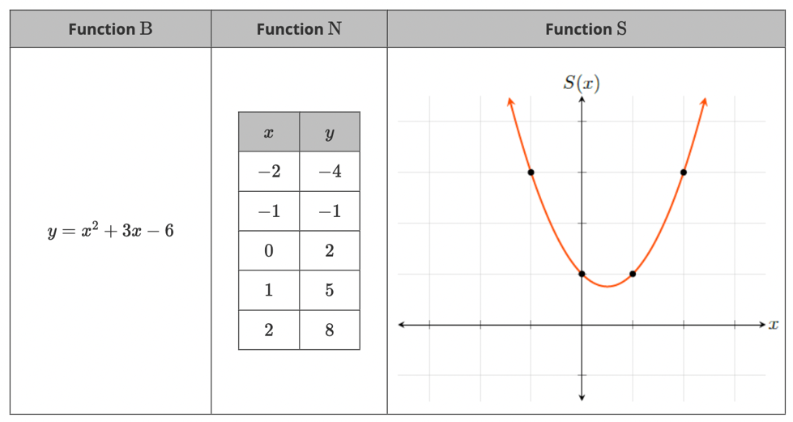
Which of the functions has a domain of $(-∞,∞)$?
Functions B, N, and S

